**Assignment 19: Python Socket Port Scanner**  
**Student ID:** Ramya-9739

**🧠 Methodology:**  
I used the Python socket module to scan ports 1–100 on scanme.nmap.org. Each port was tested with a TCP connection and the script printed whether the port was open or closed. A short delay was added between scans to reduce load.

📸 Screenshot:

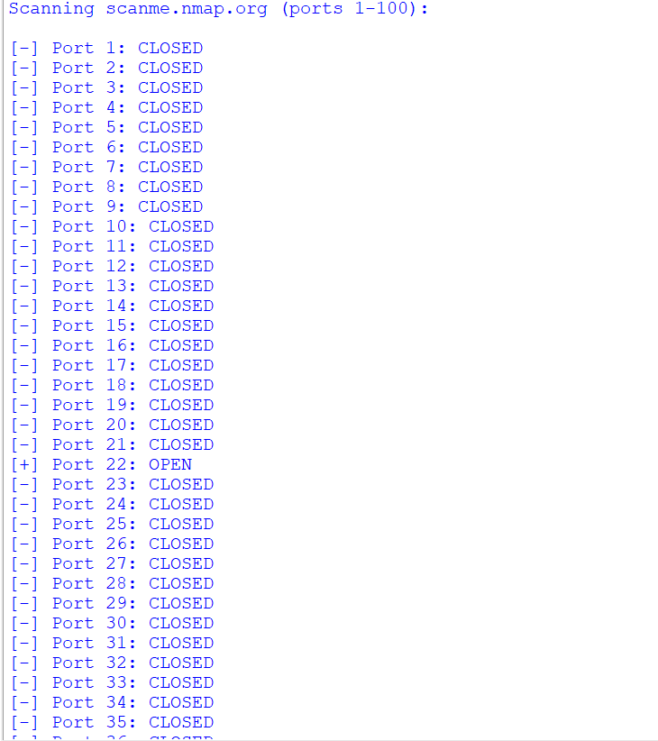

**🔍 Findings:**

* Open ports found: (e.g., 22, 80 – your result may vary)



* Closed ports were correctly reported



* Useful for understanding how port scanning works at the socket level

**📘 Conclusion:**  
This assignment helped me understand how tools like Nmap work behind the scenes. I learned how TCP connections can reveal open ports and how Python can automate this process.

**🧑‍💻 Code:**

import socket

import time

target = "scanme.nmap.org"

print(f"scanning {target} (ports 1-100):\n")

for port in range(1, 101):

s = socket.socket(socket.af_inet, socket.sock_stream)

s.settimeout(0.5)

result = s.connect_ex((target, port))

if result == 0:

print(f"[+] port {port}: open")

else:

print(f"[-] port {port}: closed")

s.close()

time.sleep(0.1)